**IP AND SUBNETTING EXERCISES**

1. Write the subnet, broadcast address and valid host range for the following:
   1. 192.168.100.17, with 4 bits of subnetting

Class C / 255.255.255.0

4 bits of subnetting = 4 extra bits to represent the network

11111111. 11111111. 11111111. 11110000 = 255.255.255.240

We turn the last octet of the ip into binary and we have 192.168.100.00010001

To calculate the network address we keep the first four bits of subnetting and the others will be 0.

192.168.100.00010000 🡪 192.168.100.16

To calculate the broadcast address, instead of 0s we replace with 1s.

192.168.100.00011111 🡪 192.168.100.31

The range of hosts discards the network and broadcast address, from 192.168.100.17 to 192.168.100.30 = 14 hosts

* 1. 192.168.100.66, with 3 bits of subnetting

Class C / 255.255.255.0

3 bits of subnetting = 3 extra bits to represent the network

11111111.11111111.11111111.11100000 = 255.255.255.224

66 into binary 🡪 01000010

192.168.100.01000000 🡪 Network address = 192.168.100.64

192.168.100.01011111 🡪 Broadcast address = 192.168.100.95

Remember the 3 bits of subnetting

For hosts, from 65 to 94 = 30 hosts

* 1. 172.16.10.5/20

Class B / 255.255.0.0

11111111. 11111111. 11110000.00000000

The last two octets are 00001010.00000101

We turn the last 12 binary digits into 0s and 1s to calculate the network and broadcast address

Network address = 172.16.0.0

Broadcast address = 172.16.15.255

The range of hosts from 0.1 to 15.254 = 4094 hosts (2 elevado a doce menos dos)

* 1. 172.16.10.33/255.255.252.0

Class B / 255.255.0.0

11111111.11111111.11111100.00000000

172.16.00001010.00100001

172.16.00001000.00000000 🡪 Network address = 172.16.8.0

172.16.00001011.11111111 🡪 Broadcast address = 172.16.11.255

2 elevado a diez menos dos = 1022 hosts

3. Given the following

a. Network address: 192.168.10.0

b. Subnet mask: 255.255.255.192

How many subnets are there? How many hosts? What are the valid subnets?

255.255.255.192 🡪 11111111. 11111111. 11111111. 11000000 🡪 /26

11 Subnets 🡪 00, 01, 10, 11 (four subnets)

000000 Hosts 🡪 2 elevado a seis menos dos = 62

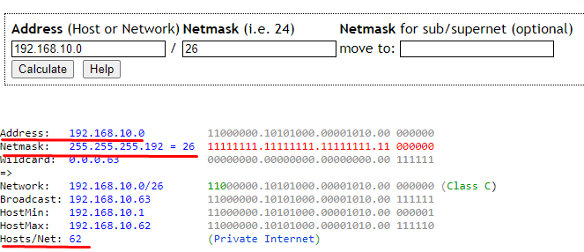

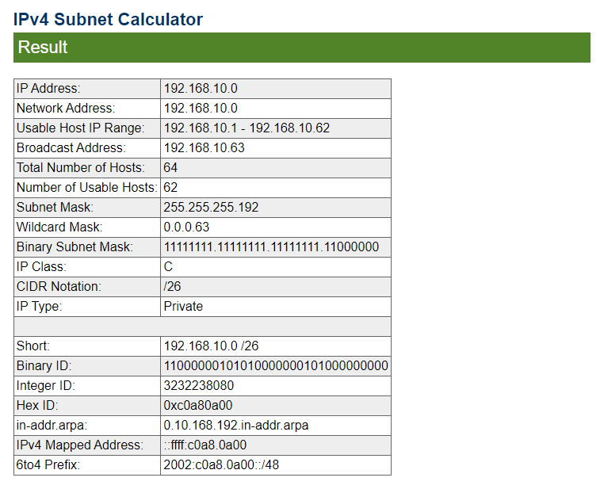

62 possible hosts for each subnet we create. 4 subnets. 2 elevado a seis menos dos = 62.

00.000000 0

01.000000 64

10.000000 128

11.000000 192

00.111111 63

01.111111 127

10.111111 191

11.111111 255